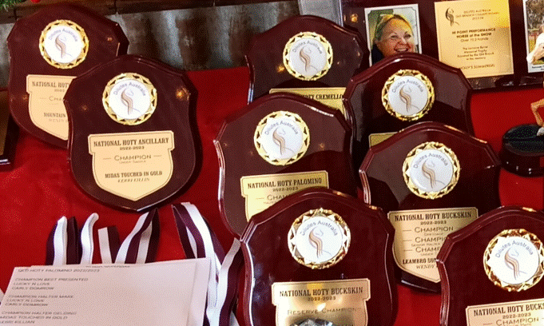
NATIONAL HOTY PALOMINO 2022/2023

CHAMPION HALTER SENIOR GELDING
MIDAS TOUCHED IN GOLD
KERRI KILLIAN

CHAMPION UNDER SADDLE
MIDAS TOUCHED IN GOLD
KERRI KILLIAN

NATIONAL HOTY BUCKSKIN 2022/2023

CHAMPION SENIOR MARE
LAZY D GAMBLERS MELODY
OLIVIA PENNISI

RESERVE CHAMPION UNDER SADDLE
LAZY D GAMBLERS MELODY
OLIVIA PENNISI

CHAMPION HACK
LAZY D GAMBLERS MELODY
OLIVIA PENNISI

RESERVE CHAMPION DRESSAGE
LAZY D GAMBLERS MELODY
OLIVIA PENNISI

CHAMPION DRESSAGE
LEAMBRO SOMELIKEITHOT
WENDY BROWN

CHAMPION SENIOR HALTER GELDING
LEAMBRO SOMELIKEITHOT
WENDY BROWN

CHAMPION UNDER SADDLE
LEAMBRO SOMELIKEITHOT
WENDY BROWN

RESERVE CHAMPION SENIOR GELDING
XTRA SMART OF SEFTON
CASEY BRUCE

NATIONAL HOTY CREMELLO 2022/2023

CHAMPION JUNIOR HALTER MARE
MOUNTAIN CRK DIOR
WENDY BROWN

CHAMPION SENIOR HALTER GELDING
SIERRA LODGE ILLUSTRATION
KRISTIE SULLIVAN

CHAMPION UNDER SADDLE
SIERRA LODGE ILLUSTRATION
KRISTIE SULLIVAN

NATIONAL HOTY NSD 2022/2023

CHAMPION SENIOR HALTER MARE
SUE’S VEGAS SHOWGIRL
SUSAN HOPKINS

NATIONAL HOTY ANCILLARY 2022/2023

CHAMPION UNDER SADDLE
MIDAS TOUCHED IN GOLD
KERRI KILLIAN

